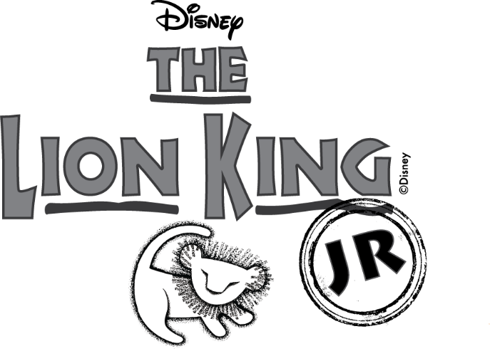

**Performance Dates**

**21st March 2023**

**22nd March 2023**

**23rd March 2023**

**7pm**

**Ticket Information to follow**

Music & Lyrics by

**Elton John & Tim Rice**

Additional Music & Lyrics by

**Lebo M, Mark Mancina, Jay Rifkin, and Hans Zimmer**

Book by

**Roger Allers & Irene Mecchi**

Based on the Broadway production directed by  
**Julie Taymor**

Music Adapted & Arranged and

Additional Music & Lyrics and  
“Luau Hawaiian Treat” written by **Will Van Dyke**

“It’s a Small World” written by **Richard M. Sherman** and **Robert B. Sherman**

Disney’s *The Lion King JR.* is presented through special arrangement with

and all authorized materials are supplied by

Music Theatre International.

421 West 54th Street, New York, NY 10019

Script, music, and all other material © 2015 Disney

Broadway Junior and MTI’s Broadway Junior Collection are trademarks

of Music Theatre International. All rights reserved

**EMMANUEL MIDDLE SCHOOL**

**presents**